Declaration and Accessing the Method:
Here is an example of a typical method declaration:
public double calculateAnswer(double wingSpan, int numberOfEngines, double length, double grossTons) {
//do the calculation here
}
The only required elements of a method declaration are the method's return type, name, a pair of parentheses, (), and a body between braces, {}.
More generally, method declarations have six components, in order:
Modifiers—such as public, private.
The return type—the data type of the value returned by the method or void if the method does not return a value.
The method name—the rules for field names apply to method names as well, but the convention is a little different.
The parameter list in parenthesis—a comma-delimited list of input parameters, preceded by their data types, enclosed by parentheses, (). If there are no parameters, you must use empty parentheses.
An exception list
The method body, enclosed between braces—the method's code, including the declaration of local variables, goes here.
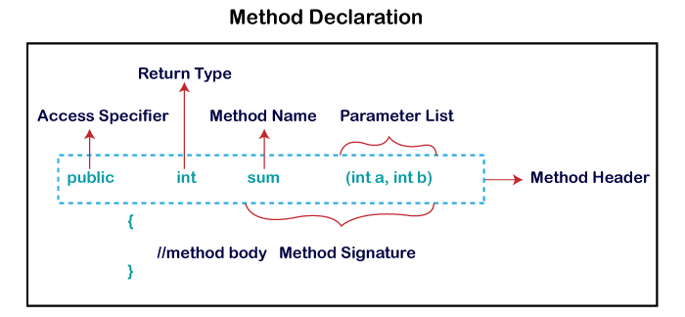

Example 1:
class MethodExample {
public String findEvenOdd(int num) {
// method body
if (num % 2 == 0)
return (num + " is even");
else
return (num + " is odd");
}
}

public class Test {
public static void main(String[] args) {
int n = 6;
String result = new MethodExample().findEvenOdd(n);
System.out.println(result);
}
}

Passing Variable and Array to the Function:

Example 2: (Passing Variables)
class Calculation {
float si;

public float calculateInterest(float p, float r, float t) {
si = (float) (p * r * t) / 100;// Simple Interest Calculation
return si;
}
}
public class Test {
public static void main(String[] args) {
// p = Principal Amount, r = Rate, t = Time in years
float result = new Calculation().calculateInterest(6000, 14, 2);
System.out.println(result);
}
}

Example 2: (Arbitrary Number of Arguments)
class TestVarargs {
public void display(String... values) {
System.out.println("display method invoked ");
for (String s : values) {
System.out.println(s);
}
}
}

public class Test {
public static void main(String[] args) {
TestVarargs tv = new TestVarargs();
tv.display();// zero argument
tv.display("Hi");// one argument
tv.display("My", "name", "is", "Mukesh");// four arguments
}
}

Example 3: (Passing array to function)
class SortArray {
public void display(int n[]) {
for (int i = 0; i < n.length; i++)
System.out.print(n[i] + " ");
}

public void sort(int n[]) {
int i, j, temp;
for (i = 0; i < n.length - i; i++) {
for (j = 0; j < n.length - i - 1; j++) {
if (n[j] > n[j + 1]) {
temp = n[j];
n[j] = n[j + 1];
n[j + 1] = temp;
}
}
}
}

}

public class Test {
public static void main(String[] args) {
SortArray sa = new SortArray();
int[] n = { 15, 25, 2, 90, 36, 44 };
System.out.println("Before sorting the array:");
sa.display(n);
sa.sort(n);
System.out.println("\nAfter Sorting the array:");
sa.display(n);
}
}

Command Line Argument:
A Java application can accept any number of arguments from the command line. This allows the user to specify configuration information when the application is launched.
The user enters command-line arguments when invoking the application and specifies them after the name of the class to be run. For example, suppose a Java application called Sort sorts lines in a file. To sort the data in a file named friends.txt, a user would enter:
java Sort friends.txt

Example 4: Command Line Argument
public class Test {
public static void main(String[] args) {
System.out.println("Your first argument is: " + args[0]);
}
}
In cmd:
javac Test.java
java Test Hello
In Eclipse:
Go to project propertyRun/Debug Settingsselect the existing optionSelect argument tabwrite any string in programme argumentsthen ok and run the programme

